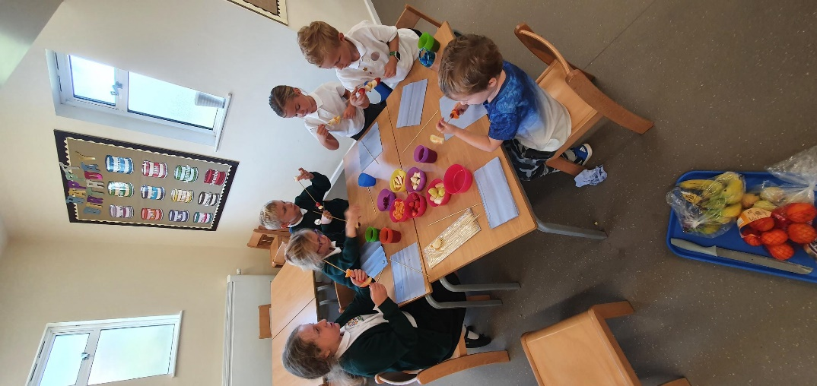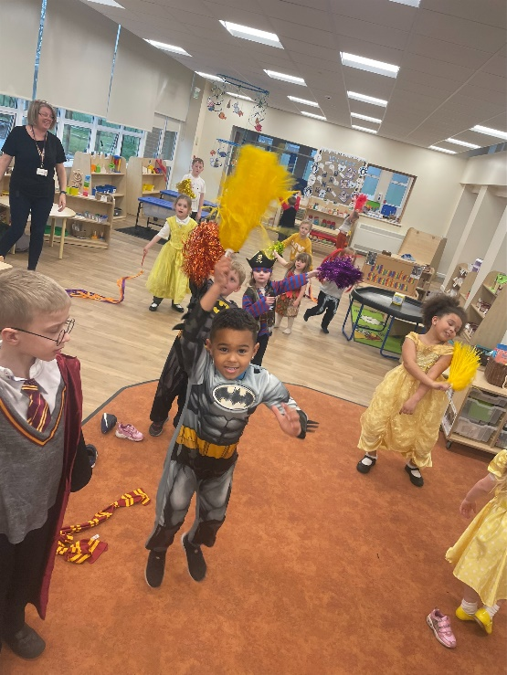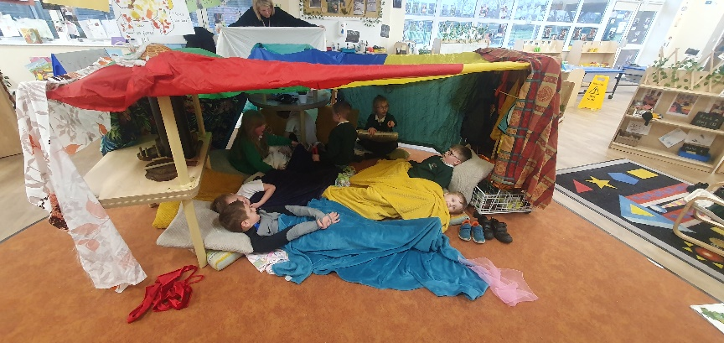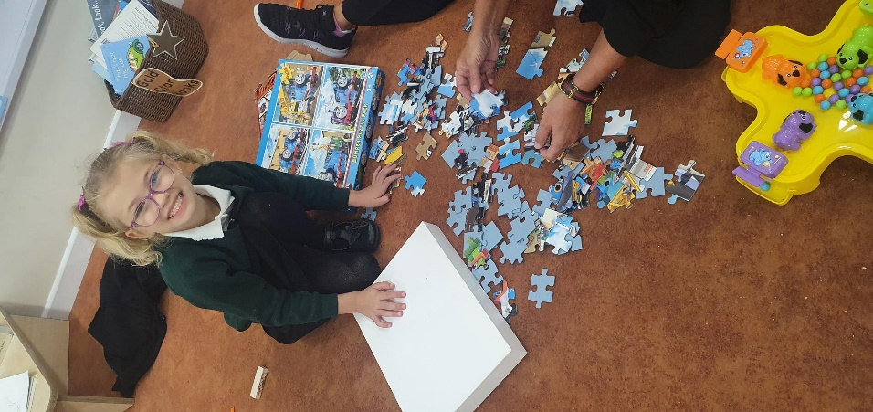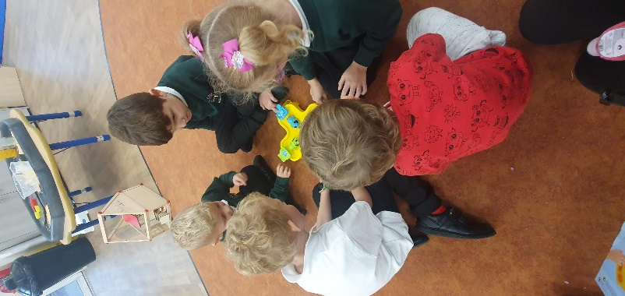

To book a place for your child(ren) please contact the main office on 01925 632705 or send a Class Dojo message to Miss Churton, as places are limited.

If you would like any further information on our wrap around offer, please contact the main office on 01925 632705 or visit the school website.

**Meadowside**

**Wraparound**

**Offer**

**Our ‘Breakfast Club’ and ‘After School Link Club’ are open!**

We would like to offer our Meadowside families the option of 'Wraparound Care' before and after school.

We provide childcare for children from **Reception to Year 6** along with a range of activities that your child can take part in.

We understand that some of our families require a little extra support and flexibility around our school start/finish times and would like to help where we can!

**Wraparound Breakfast Club**Breakfast Club will be held during term time in our school dining hall. Parents can drop off at the dining hall anytime between **8.00am and 8:30am via Fisher Avenue**. The children will have the option of a breakfast on arrival with a variety of calm activities to choose from as they wait for the class to open. The children will be taken to their classrooms for the start of the school day at 8.50 by a member of staff from the Breakfast Club.  
**Breakfast club daily rate - £2 per child  
  
Wraparound After School Link Club**The children will join us from 3:20pm to take part in a broad range of activities under the supervision of experienced school staff. We aim to provide activities that appeal to the interests of our Meadowside children.  
Wraparound after school club comprises of:  
**3:20pm – 4:30pm - £3 per child**  
Your child will join us for our activity and will be **collected by 4:30pm**.or **3:20pm – 5:15pm - £5 per child**  
This is an extension to session 1 where the children will be provided with a healthy snack following the activity with some time to wind down and relax before collection. This session will **end at 5:15**.  
  
Parents will collect the children from the Nursery shutter doors following either session.

**\*\***Please note that any children collected later than 4:30pm will be charged at a £5 daily rate. There will be a fee for late collections following the 5:15pm session.